Juliana vs. United States, Children’s Climate Lawsuit

www.ourchildrenstrust.org

Leading the game-changing, youth-driven, global climate recovery campaign to secure the legal right to a stable climate and healthy atmosphere.
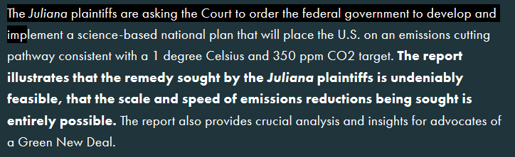

See the above mentioned report at www.ourchildrenstrust.org/350-ppm-pathways
Law suits are expensive, even with volunteer help. In Juliana, your support enables our opposition to the government’s unprecedented delay tactics, including the government's current Interlocutory Appeal to several rulings already decided in the youths’ favor. Oral argument on that Interlocutory Appeal happens June 4! Your support sustains our request that the Ninth Circuit prevent the climate crisis from getting worse, by immediately halting all new coal leasing on public lands, all new offshore exploration and extraction leases, and all new approvals for any fossil fuel infrastructure. Thus, we continue our strenuous efforts to advance young people’s constitutional and public trust rights to science-based climate recovery, with the law, facts, world renown experts, and most importantly, with your support on our side. June 4, 2019 is just the beginning of this process.
Please contribute to our lawsuits at our website ourchildrenstrust.org/donate-now

